**דגם צורות פשוטות**

|  |  |
| --- | --- |
|  |  |
|  |  |

|  |  |
| --- | --- |
|  |  |
|  |  |

|  |  |  |  |
| --- | --- | --- | --- |
|  |  |  |  |



**דגם צורות פשוטות**

|  |  |  |
| --- | --- | --- |
|  |  |  |
|  |  |  |
|  |  |  |

|  |  |  |
| --- | --- | --- |
|  |  |  |
|  |  |  |
|  |  |  |

|  |
| --- |
|  |
|  |
|  |
|  |
|  |
|  |
|  |
|  |
|  |

|  |
| --- |
|  |
|  |
|  |
|  |
|  |
|  |
|  |
|  |
|  |

|  |
| --- |
|  |
|  |
|  |
|  |
|  |
|  |
|  |
|  |
|  |



**דגם צורות מורכבות**

|  |  |
| --- | --- |
|  |  |
|  |  |

|  |  |
| --- | --- |
|  |  |
|  |  |

|  |  |  |  |
| --- | --- | --- | --- |
|  |  |  |  |



|  |  |  |
| --- | --- | --- |
|  |  |  |
|  |  |  |
|  |  |  |

**דגם צורות מורכבות**

|  |  |  |
| --- | --- | --- |
|  |  |  |
|  |  |  |
|  |  |  |

|  |
| --- |
|  |
|  |
|  |
|  |
|  |
|  |
|  |
|  |
|  |

|  |
| --- |
|  |
|  |
|  |
|  |
|  |
|  |
|  |
|  |
|  |

|  |
| --- |
|  |
|  |
|  |
|  |
|  |
|  |
|  |
|  |
|  |



**הדבקה והעתקה**

|  |  |  |
| --- | --- | --- |
|  |  |  |
|  |  |  |
|  |  |  |
|  |  |  |
|  |  |  |
|  |  |  |
|  |  |  |
|  |  |  |
|  |  |  |
|  |  |  |



|  |  |  |  |  |
| --- | --- | --- | --- | --- |
|  |  |  |  |  |
|  |  |  |  |  |

|  |  |  |  |
| --- | --- | --- | --- |
|  |  |  |  |
|  |  |  |  |
|  |  |  |  |
|  |  |  |  |
|  |  |  |  |
|  |  |  |  |
|  |  |  |  |

|  |  |  |  |
| --- | --- | --- | --- |
|  |  |  |  |
|  |  |  |  |
|  |  |  |  |
|  |  |  |  |
|  |  |  |  |
|  |  |  |  |
|  |  |  |  |

**משחק זיכרון**

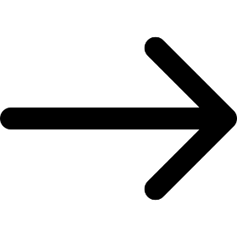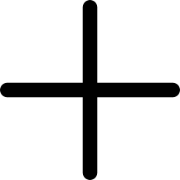





**מסלול**

**באולינג**

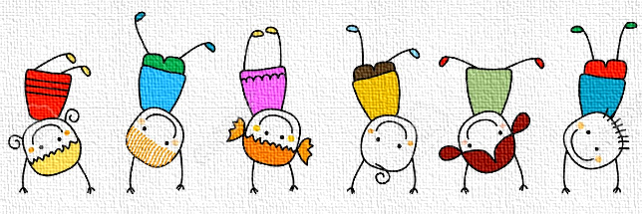

**סודוקו**

|  |  |  |  |
| --- | --- | --- | --- |
|  |  |  |  |
|  |  |  |  |
|  |  |  |  |
|  |  |  |  |

**סודוקו**

|  |  |  |  |
| --- | --- | --- | --- |
|  |  |  |  |
|  |  |  |  |
|  |  |  |  |
|  |  |  |  |

**דומינו**





**דומינו**





**כמה קלעתי?**

|  |  |  |  |  |  |
| --- | --- | --- | --- | --- | --- |
|  |  |  |  |  |  |
|  |  |  |  |  |  |
| **סיכום:** | **סיכום:** | **סיכום:** | **סיכום:** | **סיכום:** | **סיכום:** |

**תמונות לגזירה והדבקה על אטבים**

|  |  |  |  |  |  |
| --- | --- | --- | --- | --- | --- |
|  |  |  |  |  |  |

|  |  |  |  |  |  |
| --- | --- | --- | --- | --- | --- |
|  |  |  |  |  |  |

|  |  |  |  |  |  |
| --- | --- | --- | --- | --- | --- |
|  |  |  |  |  |  |



* ניתן להשלים את הטבניתן להשלים את הטבלה וסרגל הגזירה בצורות לפי בחירה אישית.

|  |  |  |
| --- | --- | --- |
| **צורה** | **כמות** |  |
|  | **2** |  |
|  | **3** |  |
|  | **3** |  |
|  | **1** |  |
|  | **2** |  |
|  | **1** |  |
|  | **3** |  |
|  | **2** |  |

**צורה - כמות**

**צורה – צבע - כמות**

|  |  |  |  |
| --- | --- | --- | --- |
| **צורה** | **צבע** | **כמות** |  |
|  |  | **3** |  |
|  |  | **5** |  |
|  |  | **6** |  |
|  |  | **2** |  |
|  |  | **4** |  |
|  |  | **8** |  |
|  |  | **1** |  |
|  |  | **5** |  |
|  |  | **6** |  |

**לוגיקה**

|  |
| --- |
|  |

|  |
| --- |
|  |

|  |  |
| --- | --- |
|  |  |

|  |  |
| --- | --- |
|  |  |

|  |  |
| --- | --- |
|  |  |

|  |  |  |
| --- | --- | --- |
|  |  |  |

|  |  |  |
| --- | --- | --- |
|  |  |  |

|  |  |  |
| --- | --- | --- |
|  |  |  |

|  |  |  |
| --- | --- | --- |
|  |  |  |

|  |  |  |  |
| --- | --- | --- | --- |
|  |  |  |  |

|  |  |  |  |
| --- | --- | --- | --- |
|  |  |  |  |

|  |  |  |  |
| --- | --- | --- | --- |
|  |  |  |  |

|  |  |  |  |
| --- | --- | --- | --- |
|  |  |  |  |

**צורות במרחב**

|  |
| --- |
|  |

|  |
| --- |
|  |

**צורות במרחב**

|  |
| --- |
|  |

|  |
| --- |
|  |

**צורה בריבוע**

|  |  |  |
| --- | --- | --- |
|  |  |  |
|  |  |  |
|  |  |  |





|  |  |  |  |  |  |  |  |  |  |  |  |  |  |  |  |  |  |  |  |  |  |  |  |  |  |  |  |  |  |
| --- | --- | --- | --- | --- | --- | --- | --- | --- | --- | --- | --- | --- | --- | --- | --- | --- | --- | --- | --- | --- | --- | --- | --- | --- | --- | --- | --- | --- | --- |
| |  |  |  | | --- | --- | --- | |  |  |  | |  |  |  | |  |  |  | | |  |  |  | | --- | --- | --- | |  |  |  | |  |  |  | |  |  |  | | |  |  |  | | --- | --- | --- | |  |  |  | |  |  |  | |  |  |  | |
| |  |  |  | | --- | --- | --- | |  |  |  | |  |  |  | |  |  |  | | |  |  |  | | --- | --- | --- | |  |  |  | |  |  |  | |  |  |  | | |  |  |  | | --- | --- | --- | |  |  |  | |  |  |  | |  |  |  | |







|  |  |  |  |  |  |
| --- | --- | --- | --- | --- | --- |
|  |  |  |  |  |  |
|  |  |  |  |  |  |
|  |  |  |  |  |  |
|  |  |  |  |  |  |
|  |  |  |  |  |  |

**מטריצה**

**מטריצה**

|  |  |  |  |  |  |  |  |
| --- | --- | --- | --- | --- | --- | --- | --- |
|  |  |  |  |  |  |  |  |
|  |  |  |  |  |  |  |  |
|  |  |  |  |  |  |  |  |
|  |  |  |  |  |  |  |  |
|  |  |  |  |  |  |  |  |
|  |  |  |  |  |  |  |  |